Some Statistics

The importance of accessibility
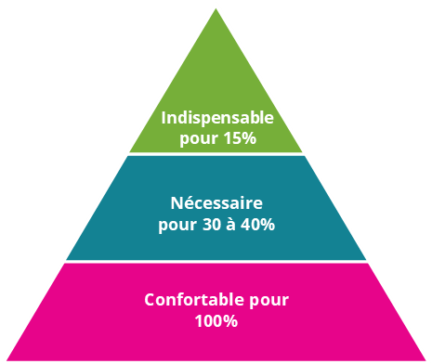
Crucial for 15%
Necessary for 30-40%
Comfortable for 100%
“An accessible environment is a crucial requirement for 10% of the population, it is necessary for 30-40%, and it is comfortable for 100%.”
Extract translated from Economic Impulses of Accessible Tourism for All, Study commissioned by the Federal Ministry of Economics and Technology, Berlin, 2004, p.13.

Number of people with disabilities worldwide

Number of people with disabilities in the world (15%)
Source: World report on disability by WHO and the World Bank, 2011.

Link between age and functional disability
Link between age and disability at a functional level 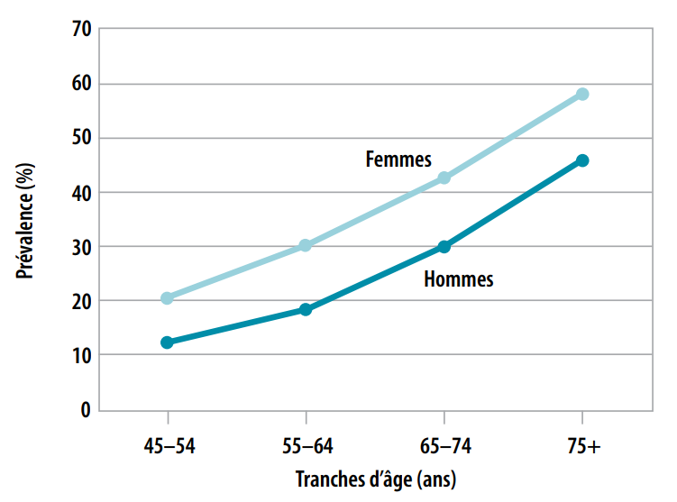
Prevalence (%), Female, Male, Age group (years)
Source: World report on disability, 2011, p.35, http://www.who.int/disabilities/world_report/2011/en/

People with reduced mobility who travel accompanied

People with disabilities, Elderly people, Average
People with reduced mobility are less likely to travel alone. On average, people with special accessibility needs in Europe travel with around 1.9 companions.
- People with disabilities travel with 2.2 companions
- Elderly people travel with 1.6 companions
Source : GFK – Key Findings, Powerpoint presentation, 2015, p.81, http://ec.europa.eu/DocsRoom/documents/5567/attachments/1/translations/en/renditions/native

2nd World Summit on Accessible Tourism - Destinations for All:
Brussels, 1-2 October 2018
The Egg Conference Centre
https://www.destinationsforall2018.eu/

About CAWaB
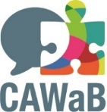
Since 2006, the Collectif Accessibilité Wallonie-Bruxelles has served as the umbrella organisation for about 20 associations representing people with reduced mobility as well as experts in the field of accessibility. It advocates for universal accessibility in the spirit of the UN Convention on the Rights of Persons with Disabilities. http://www.cawab.be/
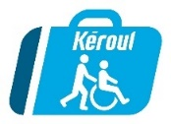
About Kéroul
Kéroul is a non-profit organisation, which promotes and develops accessible tourism and culture for persons with limited physical ability. Founded in Montreal in 1976, Kéroul is a key consultant on accessibility issues for the Ministry of Tourism of Quebec. http://www.keroul.qc.ca/
Press contact
CAWaB - Mathieu Angelo, director, ma@cawab.be, +32 (0)493 88 83 89

