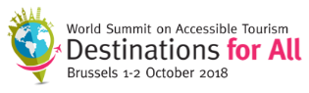

Examples of Good Practice and Real Projects

The ‘Destinations for All’ World Summit will take place in Brussels on the 1st and the 2nd of October 2018. It will present good practices that ensure tourism can be enjoyed by everyone and other key topics.
Here, we present five examples of good practice, each chosen to illustrate one of the five topics around which the Summit has built its programme. There are explanations and press contacts for each project.

Topic 1: Destination Management
Before undertaking a trip, people want to make sure they can reach their destination, stay there and take advantage of the services on offer. The quality and availability of precise information on the destination is therefore crucial for tourists with specific needs.

Know Before You Go
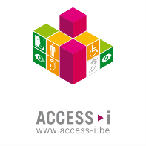
Green, orange, white: these are the three colours used by Access-i certification, which allows users to assess the accessibility of a building, a concert hall, a particular site or an event.
In practical terms, each category of people with specific needs is identified by a pictogram. This is placed in a box whose colour varies according to the level of accessibility of the space in question. If the box is green, the site is accessible independently. If it’s orange, the site is accessible but requires assistance. If it’s white, an information sheet is available, to allow the public to evaluate the conditions of the visit.
Access-i certifies existing sites and publishes a regularly updated online directory of them all (www.access-i.be). It is a comprehensive and useful source of information.

Press Contact
Access-i
Sandra Janssens (Communication project manager)
Rue Nanon 98, 5000 Namur, Belgium
Telephone: +32(0) 81 39 08 78 or +32(0) 473 76 64 28 (mobile)
info@access-i.be
www.access-i.be
Topic 2: Hosting and Security
Beyond the physical layout of the premises and buildings, the quality of the welcome is paramount at all levels of the tourism industry. The needs of all customers must be taken into account, and the teams in place must provide react appropriately.

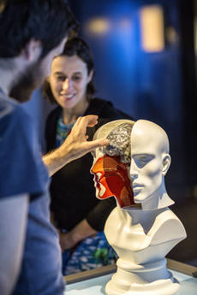
Please Touch!
At the Cité des sciences et de l'industrie in Paris, staff invite you to discover objects using all your senses, especially your hands, the motto is "Please touch!". Each exhibition aims to be accessible to all: children, adults, wheelchairs users, the hard of hearing, those who don't speak the same language, blind or partially sighted visitors, those with mental disabilities and the elderly.
The Cité des sciences believes that improving accessibility improves everyone’s quality of life, and has made it a key objective. Tactile displays with diagrams in relief, texts in Braille, tours and events in both French and international sign language are provided to better understand scientific concepts. Wheelchairs or pushchairs are available for visiters. A guide is also available to organise tours for visiters with specific needs.
The Cité des sciences has commited to respecting an accessibility charter to improve the safety and comfort of all its visitors- and it works!

Press contact
Cité des sciences et de l’industrie - a Universcience site
Sabine Tuyaret (Head of quality of use and accessibility)
30 avenue Corentin Cariou, 75019 Paris, France
Telephone : +33(0)1 40 05 72 03 or + 33 (0)6 33 42 84 60 (mobile)
Sabine.tuyaret@universcience.fr

http://www.cite-sciences.fr/en/accessible-cite/

Topic 3: Accommodation
Advances in universal design invite us to imagine a new way of thinking, understanding and building. This approach also applies to the accommodation sector, which is an essential link in the tourism chain.

15 Years of Excellence
Scandic, the Swedish accommodation chain, has been working on the issue of accessibility for all its hotels and locations since 2003.
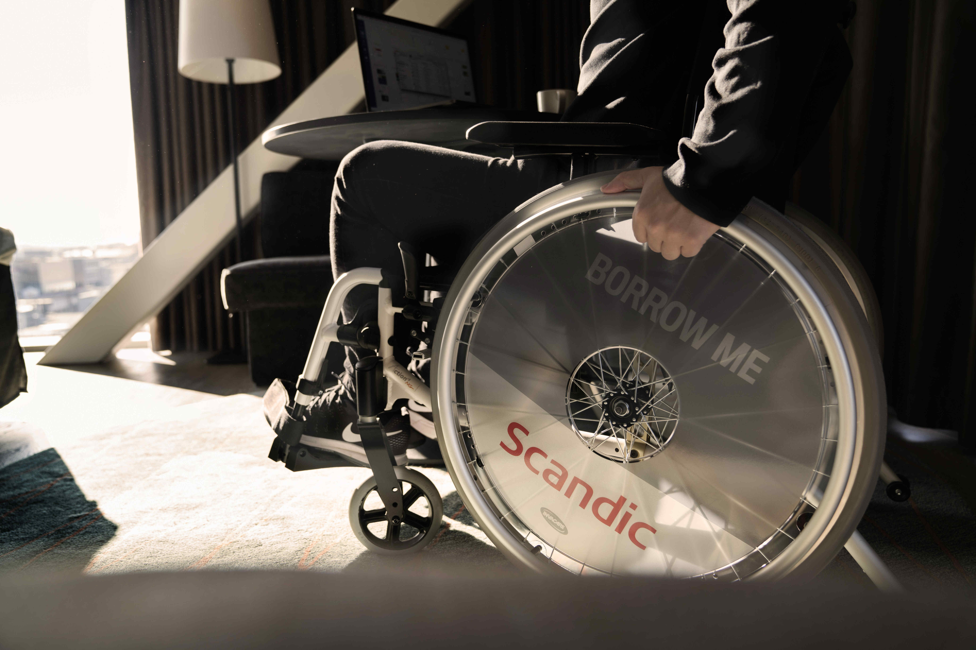
During the last 15 years, the hotel chain has won many awards. Scandic’s management and staff have made accessibility a strategic issue by taking practical measures to ensure that, whatever the disability, it is entirely possible for people to take part in events, spend the night and use the hotel facilities just like any other guests.
Scandic’s successful strategy includes a 135-point checklist that has been implemented throughout the hotel chain.
The group’s 16,000 members of staff also undergo interactive online accessibility training, which includes tests, advice and educational videos showing how to provide superior quality service to people with disabilities.

More information
Scandic
www.scandichotels.com/always-at-scandic/special-needs

Topic 4: Transport and Mobility
At their destination, tourists need to be able to move around easily, whatever their needs and the means of transport chosen. Strategies and partnerships must be developed and implemented in order to guarantee their mobility.

From 25 to 100,000 Trips a Year
It is possible to get around easily in a wheelchair without having to call on the help of 5 people, a minibus and lots of energy. In fact, to improve the mobility of people with specific needs it is better not to!
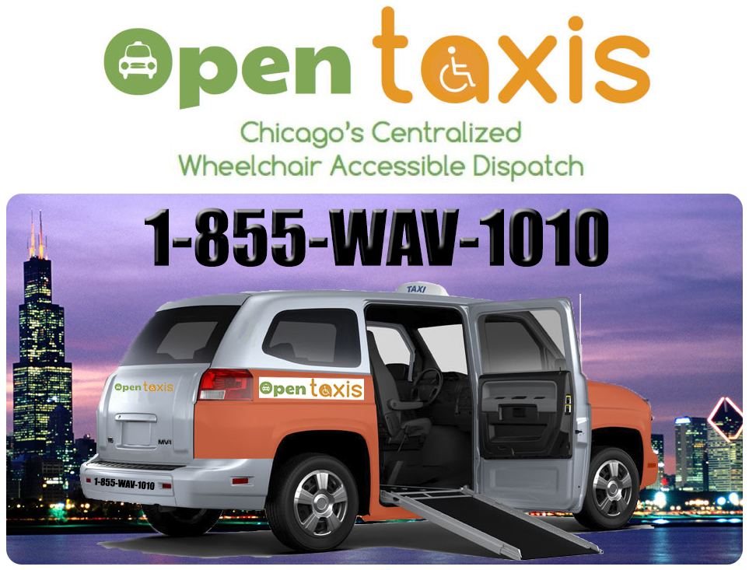
This is the challenge taken on by Open Taxis, a company from Chicago. Founded in 2013, with the aim of setting up an efficient, centralised wheelchair-accessible taxi system under the current legislation, Open Taxis celebrated 100,000 journeys a year in 2018.
While the Chicago authorities’ initial desire to require a minimum number of taxis to be accessible to persons with reduced mobility was commendable, in practice this resulted in a situation where non-centralised mini services operated side by side with available taxis that were not being used efficiently.
Open Taxis developed a smartphone application, a dedicated central dispatch number and has considerably improved the management of all wheelchair accessible taxis in Chicago.
Mission accomplished! People with reduced mobility can travel more easily, in a way that is now part of city life. Open Taxis has proved that with a partnership approach, some incentives and appropriate legislation, there can be equality in the transport-on-demand sector.

Press contact
Open taxis (An Open Doors Organisation service)
Eric Lipp (Founder and director of the Open Doors Organization and Open taxis)
8600 W. Catalpa Ave, Suite 709, Chicago, IL (60656), USA
Telephone: +1 855 928 1010
ericlipp@opendoorsnfp.org
www.opentaxis.com and www.opendoorsnfp.org

Topic 5: Leisure Products and Activities
The tourism industry is very good at identifying holiday trends and responding to the resulting range of demands. Now it has a duty to take into account tourists’ individual needs by offering a full range of tourist products and activities.
These can be divided into two broad categories: inclusive products and activities aimed at a whole group looking for a ‘shared’ experience, and products and activities that are specifically adapted to the needs of different groups.

Getting Up Close and Personal with African Lions and Experiencing Adventures All Over the World
Why not watch a herd of antelopes, admire the wildebeest migration, track lions and find rhinoceros footprints? This extraordinary discovery experience in great African animal reserves is also accessible to people with specific needs.
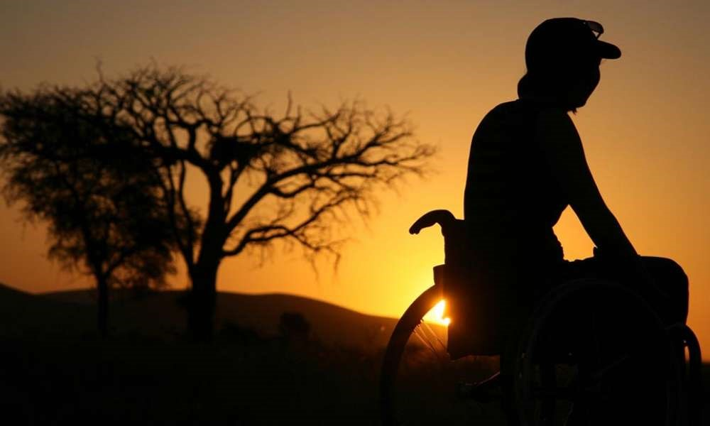
Travability.travel specialises in holiday destinations that are accessible to all. The holidays they offer cover every continent and every budget, including visits to the Kennedy Space Center in the United States, to Angkor Wat in Cambodia or discovering Portugal and Jordan.
Initially launched in 2007 with the aim of promoting tourist activities that are accessible to all, Travability.travel quickly became an ‘agent of change’, working to encourage cultures around the world to see disability as an integral part of life.
In real terms, Travability.travel seeks to motivate players in the tourism industry to allow them to create accessible environments that enable inclusion in an economically sustainable way.

Press contact
Travability.travel
Bill Forrester (Co-founder)
17 Wells Street, Frankston, Vic (3199), Australia
bill@travability.travel
www.travability.travel

